CGS System
# Source: AI Source: Provided by: [Data Path: Persons Table -> ID Column: 1, Name_En Column: Motasem Essam] -> From: [ChatGPT] on [7/17/2026]
The CGS System (Centimeter–Gram–Second System) is a metric measurement system that uses the centimeter (cm) as the unit of length, the gram (g) as the unit of mass, and the second (s) as the unit of time. It was one of the earliest standardized systems of scientific measurement and served as an important predecessor to the MKS and International System of Units (SI).
The CGS system was widely used in physics, chemistry, astronomy, and electromagnetism, particularly during the late 19th and early 20th centuries.

Definition
# Source: AI Source: Provided by: [Data Path: Persons Table -> ID Column: 1, Name_En Column: Motasem Essam] -> From: [ChatGPT] on [7/17/2026]
The CGS System is a metric measurement system based on three fundamental units:
- Centimeter (cm) for length
- Gram (g) for mass
- Second (s) for time
Its name comes from the initials of these three base units:
$$\boxed{\text{CGS}=\text{Centimeter–Gram–Second}}$$

History
# Source: AI Source: Provided by: [Data Path: Persons Table -> ID Column: 1, Name_En Column: Motasem Essam] -> From: [ChatGPT] on [7/17/2026]
The CGS system was introduced in the 19th century to standardize scientific measurements.
Key milestones:
- 1832 – Carl Friedrich Gauss promoted a coherent measurement system for scientific work.
- 1874 – The British Association for the Advancement of Science formally adopted the CGS system.
- 20th century – Gradually replaced by the MKS system and later by the SI system.

Characteristics
# Source: AI Source: Provided by: [Data Path: Persons Table -> ID Column: 1, Name_En Column: Motasem Essam] -> From: [ChatGPT] on [7/17/2026]
The CGS system is:
- Metric-based.
- Decimal-based.
- Coherent.
- Based on three fundamental units.
- Primarily designed for scientific calculations.

Fundamental Units
# Source: AI Source: Provided by: [Data Path: Persons Table -> ID Column: 1, Name_En Column: Motasem Essam] -> From: [ChatGPT] on [7/17/2026]
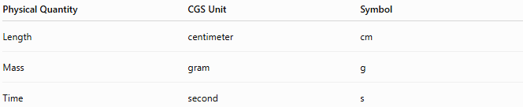
Physical Quantity | CGS Unit | Symbol
Length | centimeter | cm
Mass | gram | g
Time | second | s

Base Units
# Source: AI Source: Provided by: [Data Path: Persons Table -> ID Column: 1, Name_En Column: Motasem Essam] -> From: [ChatGPT] on [7/17/2026]
1. Centimeter (cm)
Measures:
- Length
- Distance
- Height
- Width
Relationship:
$$1\text{ cm}=0.01\text{ m}$$

2. Gram (g)
Measures:
- Mass
Relationship:
$$1\text{ g}=0.001\text{ kg}$$

3. Second (s)
Measures:
- Time
Relationship:
$$1\text{ s}=1\text{ s}$$
(The unit of time is the same in both the CGS and SI systems.)

Derived Units
# Source: AI Source: Provided by: [Data Path: Persons Table -> ID Column: 1, Name_En Column: Motasem Essam] -> From: [ChatGPT] on [7/17/2026]
Many physical quantities are derived from the three base units.
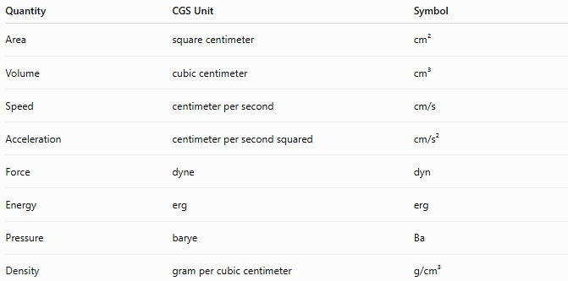
Quantity | CGS Unit | Symbol
Area | square centimeter | cm²
Volume | cubic centimeter | cm³
Speed | centimeter per second | cm/s
Acceleration | centimeter per second squared | cm/s²
Force | dyne | dyn
Energy | erg | erg
Pressure | barye | Ba
Density | gram per cubic centimeter | g/cm³

Common Derived Units
# Source: AI Source: Provided by: [Data Path: Persons Table -> ID Column: 1, Name_En Column: Motasem Essam] -> From: [ChatGPT] on [7/17/2026]
Force
The CGS unit of force is the dyne.
Definition:
A dyne is the force required to accelerate a mass of 1 gram at 1 centimeter per second squared.
$$\boxed{1\text{ dyn}=1\text{ g}⋅\text{cm}/{\text{s}}^{2}}$$
Relationship to SI:
$$1\text{ dyn}={10}^{-5}\text{ N}$$

Energy
The CGS unit of energy is the erg.
Definition:
An erg is the work done by a force of one dyne acting through a distance of one centimeter.
$$\boxed{1\text{ erg}=1\text{ dyn}⋅\text{cm}}$$
Relationship to SI:
$$1\text{ erg}={10}^{-7}\text{ J}$$

Pressure
The CGS unit of pressure is the barye.
Definition:
$$\boxed{1\text{ Ba}=1\text{ dyn}/{\text{cm}}^{2}}$$

Examples
# Source: AI Source: Provided by: [Data Path: Persons Table -> ID Column: 1, Name_En Column: Motasem Essam] -> From: [ChatGPT] on [7/17/2026]
Example 1
Length
$$25\text{ cm}$$

Example 2
Mass
$$500\text{ g}$$

Example 3
Speed
$$120\text{ cm/s}$$

Example 4
Force
$$15\text{ dyn}$$

Advantages
# Source: AI Source: Provided by: [Data Path: Persons Table -> ID Column: 1, Name_En Column: Motasem Essam] -> From: [ChatGPT] on [7/17/2026]
The CGS system:
- Is simple and coherent.
- Is well suited for laboratory-scale measurements.
- Uses decimal conversions.
- Historically simplified scientific calculations.
- Was widely adopted in early physics.

Disadvantages
# Source: AI Source: Provided by: [Data Path: Persons Table -> ID Column: 1, Name_En Column: Motasem Essam] -> From: [ChatGPT] on [7/17/2026]
The CGS system:
- Uses units that are inconvenient for many engineering applications.
- Has multiple variants for electromagnetic quantities (such as electrostatic and electromagnetic CGS systems), leading to inconsistency.
- Has largely been replaced by the SI system.

Applications
# Source: AI Source: Provided by: [Data Path: Persons Table -> ID Column: 1, Name_En Column: Motasem Essam] -> From: [ChatGPT] on [7/17/2026]
Historically, the CGS system was used in:
- Classical mechanics
- Physics
- Chemistry
- Astronomy
- Electromagnetism
- Scientific research
- Laboratory measurements
Today it is mainly encountered in:
- Older scientific literature
- Historical research
- Some specialized physics fields

Everyday Examples
# Source: AI Source: Provided by: [Data Path: Persons Table -> ID Column: 1, Name_En Column: Motasem Essam] -> From: [ChatGPT] on [7/17/2026]
Although uncommon in everyday life today, the CGS system may still appear in:
- Scientific textbooks published before SI became universal.
- Older laboratory manuals.
- Historical physics papers.
- Material density values expressed in g/cm³.

Common Mistakes
# Source: AI Source: Provided by: [Data Path: Persons Table -> ID Column: 1, Name_En Column: Motasem Essam] -> From: [ChatGPT] on [7/17/2026]
- Confusing grams with kilograms.
- Mixing CGS and SI units in calculations.
- Forgetting that the CGS unit of force is the dyne, not the newton.
- Assuming CGS is the modern international standard.

Key Points
# Source: AI Source: Provided by: [Data Path: Persons Table -> ID Column: 1, Name_En Column: Motasem Essam] -> From: [ChatGPT] on [7/17/2026]
- The CGS system stands for Centimeter–Gram–Second.
- It uses the centimeter, gram, and second as its base units.
- It is a decimal-based metric system.
- Important derived units include the dyne (force) and the erg (energy).
- It has been largely replaced by the SI system but remains historically significant.

CGS System vs. SI System
# Source: AI Source: Provided by: [Data Path: Persons Table -> ID Column: 1, Name_En Column: Motasem Essam] -> From: [ChatGPT] on [7/17/2026]
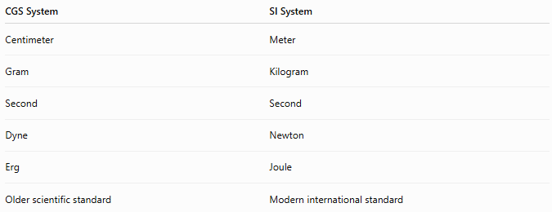
CGS System | SI System
Centimeter | Meter
Gram | Kilogram
Second | Second
Dyne | Newton
Erg | Joule
Older scientific standard | Modern international standard

CGS System vs. MKS System
# Source: AI Source: Provided by: [Data Path: Persons Table -> ID Column: 1, Name_En Column: Motasem Essam] -> From: [ChatGPT] on [7/17/2026]
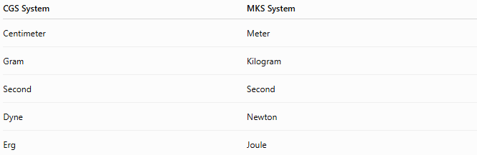
CGS System | MKS System
Centimeter | Meter
Gram | Kilogram
Second | Second
Dyne | Newton
Erg | Joule

CGS System vs. Metric System
# Source: AI Source: Provided by: [Data Path: Persons Table -> ID Column: 1, Name_En Column: Motasem Essam] -> From: [ChatGPT] on [7/17/2026]
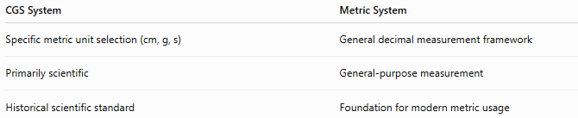
CGS System | Metric System
Specific metric unit selection (cm, g, s) | General decimal measurement framework
Primarily scientific | General-purpose measurement
Historical scientific standard | Foundation for modern metric usage

Conclusion
# Source: AI Source: Provided by: [Data Path: Persons Table -> ID Column: 1, Name_En Column: Motasem Essam] -> From: [ChatGPT] on [7/17/2026]
The CGS (Centimeter–Gram–Second) System is a metric measurement system based on the centimeter, gram, and second as its fundamental units. It played a major role in the development of modern scientific measurement and introduced important derived units such as the dyne for force and the erg for energy. Although it has been largely replaced by the International System of Units (SI), the CGS system remains historically significant and continues to appear in older scientific literature and certain specialized fields of physics.

